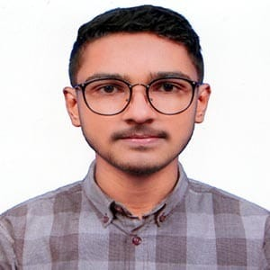
CURRICULUM VITAE
Mahfujur Rahman Jisan
Contact No: 01716055781
E-mail: mehfuzzeeshan@gmail.com
Facebook: Zeeshan Mehfuz
Address: 40A house, Tilagor,Sylhet

CAREER OBJECTIVE
To obtain a position with opportunities to utilize my technical, branding and skill, talent, creativity, sincerity for the better achievement of the organization.
PERSONAL DETAILS
Full Name : Mahfujur Rahman Jisan
Father’s Name : Habibur Rahman
Mother’s Name : Fatema Mojumder
Village : Gazinagar
Post Office : Sunachong Bazar
Thana : Chunarughat
District : Habigonj
Date of Birth : 16 Dec, 2005
Sex : Male
Religion : Islam
Marital Status : Single
Nationality : Bangladeshi
Blood Group : B(+)
Language | Speaking | Writing | Reading
Bangla | High | High | High
English | High | High | High
Hindi | High | Medium | Medium
LANGUAGE EFFICIENCY

ACADEMIC QUALIFICATION
Degree | Department | Institute | Passing year | CGPA
B.Sc | Computer Science and Engineering | Leading University | 2028 | 4.97/4.00
HSC | Science | Brindaban Govt. College | 2023 | 5.00/5.00
SSC | Science | D.C.P High School | 2021 | 5.00/5.00

COMPUTER SKILLS
- Application Software: MS office, Adobe Photoshop,MS Word,Adobe illustrator

- Networking & Internet: Internet Browsing Social media, E-mail etc.

- Programming : Python, Html, C, C++, Java, Dart .

EXTRA CURRUCULAR ACTIVITIES
- Member of the blood Donor’s Organization “Save Life’s”.
- Was a active member of Brindaban Govt. College English debating club.
- Playing Cricket and Football.
- Member of “Ensure fundamentals for Human”.
SKILLS

LEISURE TIME ACTIVITY

HOBBIES

REFERENCES

ABC Ahmed WXY
Assistant Professor, Dept. of CSE Lecturer, Dept. of CSE
Leading University Leading University
Contact: 0123456789 Contact: 0987654321
Email:abcahmed@gmail.com E-mail: wxy@gmail.com

I, the undersigned, hereby declare that the above information is true and I will be responsible for any wrong information.

Sincerely Yours

Date: 28 Sep, 2024
Mahfujur Rahman Jisan

